Please follow the below mentioned steps to deploy gva to cloud:

**Step 1**: Steps to be followed for creating the **ICLP-Phase1-prod-intel file.**

Create the SDS file (ICLP-Phase1-prod-intel). For doing that, please follow the below steps:

1. Create the ICLP-Phase1-prod-intel folder.
2. Follow the given path “castle_canyon_cloud-gva/build/deployScripts/azure” and select the **assets** and **core** folder and copy into the **ICLP-Phase1-prod-intel** folder (make sure the name of the folder should me same as mentioned).

**Step 2: Changes required to make in scripts and ICLP-Phase1-prod-intel:**

1. Create the docker image of VP and GVA source code you need to deploy into the instance.
2. Provide the correct docker credentials and the docker image into both the scripts- setup_gva_app_p1.sh and setup_vp_app_p1.sh. (lines of scripts which needs to be updated marked as yellow in below screenshot)

**(Note: After editing, please make sure the scripts should be saved in UNIX format).**

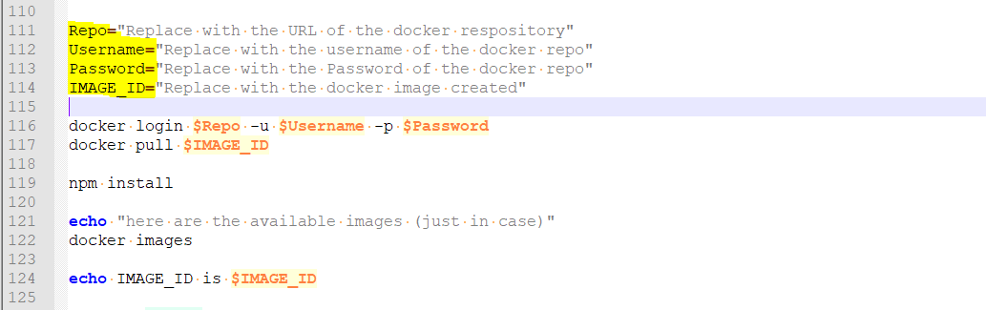

1. Generate SAS URL for files inside ‘iclp’ container (**Please refer step 3 for iclp container**).

For generating SAS URL, follow the steps given below for each files inside the mentioned containers.

* Click on the files uploaded in the containers mentioned above in Azure Portal.
* Click on the Generate SAS tab.
* Select Permissions as “READ” and Expiry as “2030-12-31” and click on the ‘Generate SAS token and URL’ button.
* Copy the generated SAS URL.

1. Provide the generated SAS URL’s in the SDS zip file (ICLP-Phase1-prod-intel).

For doing that, edit the run.csx file inside “ICLP-Phase1-prod-intel\core\functions\createAADApplication” as mentioned below.

* Edit the below given lines of code (Line number 99 to 102) with the corresponding SAS URLs generated in the previous step.

oVpBootupScriptURL="<TO-BE-REPLACED-WITH-setup_vp_app_p1-SAS-URL>",

oGvaBootupScriptURL="<TO-BE-REPLACED-WITH-setup_gva_app_p1-SAS-URL>",

1. After making all the changes into “ICLP-Phase1-prod-intel\core\functions\createAADApplication” Zip the folder by right clicking the mouse.

**Step 3: Changes required to create new blob files for ICLP phase1:**

1. Create a Azure storage account (select “Account kind” as “Blob” and “Replication” as “Locally Redundant Storage”) and create the below containers in it.

* addresses (select Access Level as Blob)
* iclp (select Access Level as Private)

1. Copy the below json file and upload as new file named – “shipmentCreation.json” inside “addresses” container created above.

* <https://iclpstoragep2.blob.core.windows.net/addresses/shipmentCreation.json>

1. Copy the below attached shell scripts and upload as new files named – “setup_vp_app_p1.sh” and “setup_gva_app_p1.sh” under “iclp” container created above.

 

**Step 4**: Sign In to <https://sds.azureiotsolutions.com> with your azure credentials. Click on “Solution Authoring”

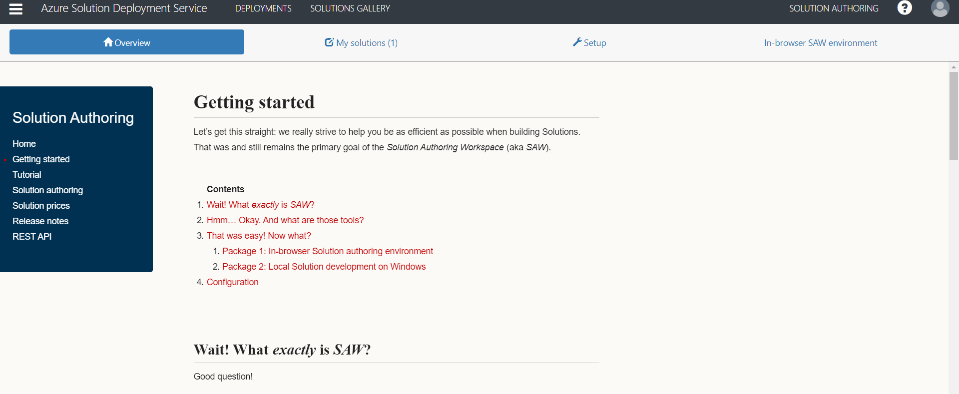

**Step 5**: Click on Setup and turn ON the authoring feature. Once the configuration progress updates to the Ready Status. Click on In-browser SAW environment.

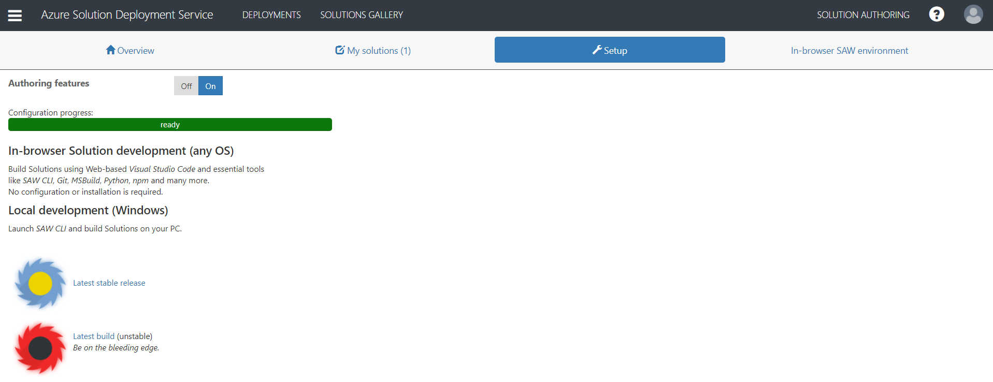

**Step 6**: Select Open in new window option from drop down menu (In-browse SAW environment)

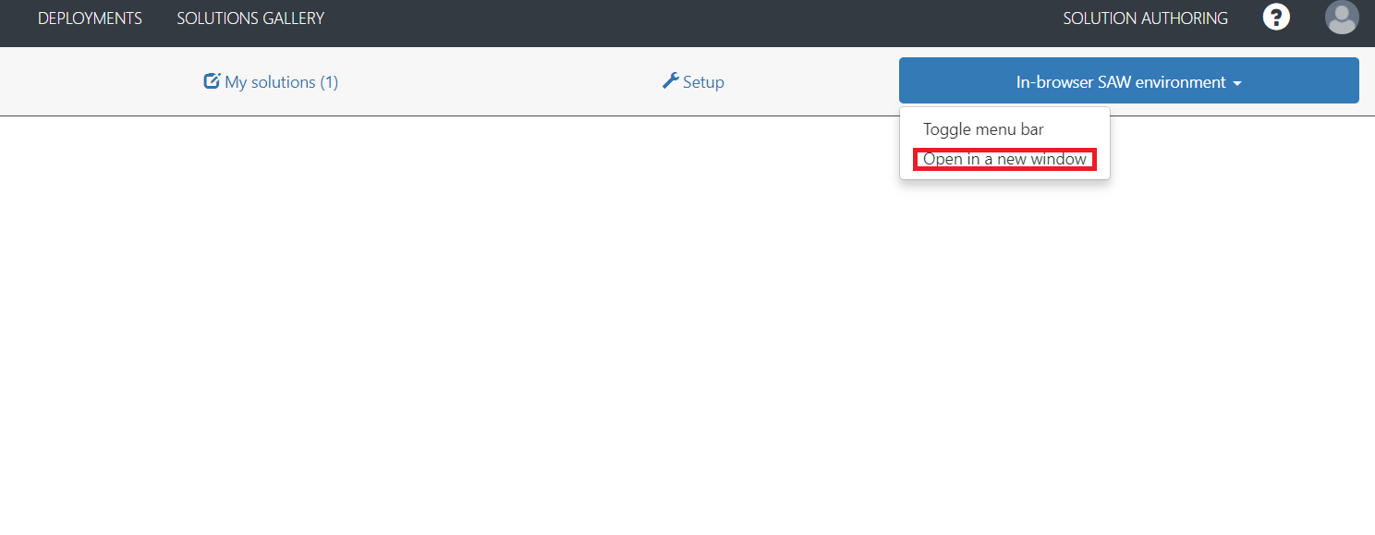After selecting new window option you can see the below screen on your browser: 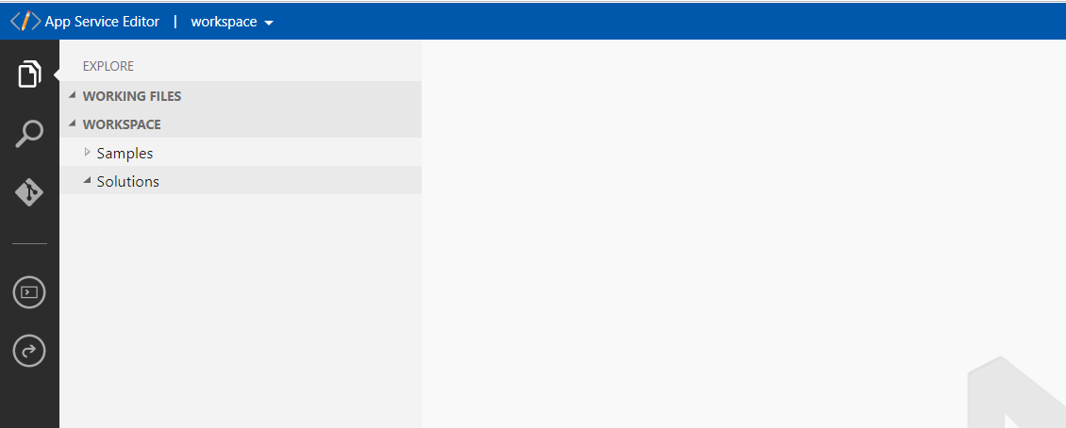

**Step 7**: Select Solutions from the left side panel and right click. Select upload file option.

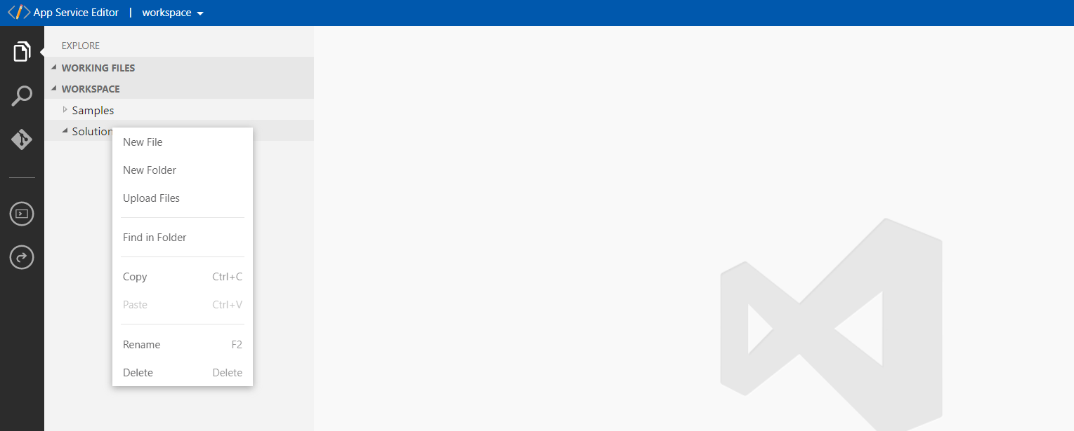

After selecting the option please upload the zip file (in this case we are loading the ICLP-Phase1-prod-intel.zip file).

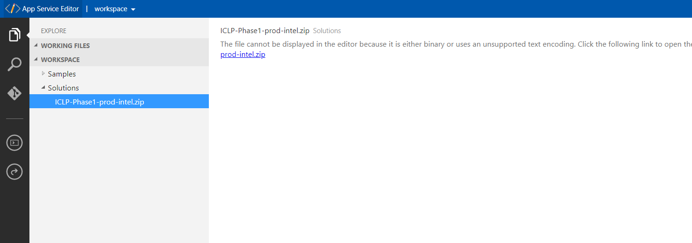

Extract the zip file and in console enter the command <<saw push>>.

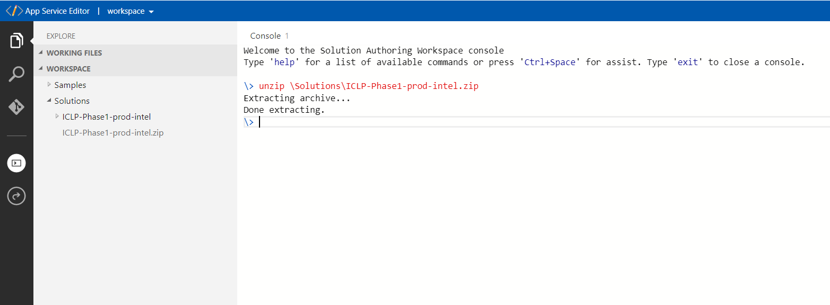

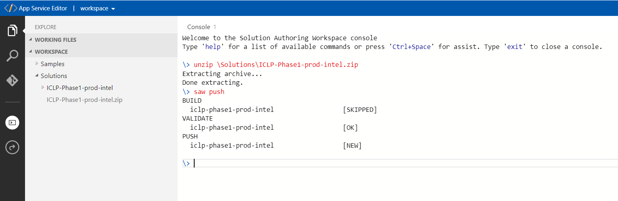

**Step 8**: Go back to Azure Solution Deployment service window and select “My solutions”. Click the icon and from drop down menu select Deploy.

